Navis Beverage and Mini Bar Inventory

BACHELOR OF TECHNOLOGY
In
FRESHMAN ENGINEERING DEPARTMENT
By

RUHITHA.P 2520080053
ANANYA.M 2520080069
VAISHNAVI.S 2520030326

Under the Esteemed Guidance of

Dr. Ramya Krishna
Assistant Professor
Department of Computer Science and Engineering




K L (Deemed to be) University DEPARTMENT OF COMPUTER SCIENCE ENGINEERING



Declaration

The Project Report entitled “Navis Beverage and Mini Bar Inventory” is a record of Bonafide work of P.RUHITHA – 2520080053, ANANYA.M - 2520080069, VAISHNAVI.S - 2520030326 submitted in partial fulfillment for the award of B. Tech in Computer Science and Engineering (or) Computer Science and Information Technology to the KLH University. The results embodied in this report have not been copied from any other departments/University/Institute.

RUHITHA.P - 2520080053
ANANYA.M - 2520080069
VAISHNAVI.S - 2520030326

K L (Deemed to be) University

DEPARTMENT OF COMPUTER SCIENCE ENGINEERING

&

DEPARTMENT OF COMPUTER SCIENCE AND INFORMATION TECHNOLOGY



CERTIFICATE

This is certify that the mini project based report entitled “Navis Beverage and Mini Bar Inventory” is a Bonafide work done and submitted by P. RUHITHA – 2520080053, ANANYA.M - 2520080069, VAISHNAVI.S - 2520030326
in partial fulfillment of the requirements for the award of the degree of BACHELOR OF TECHNOLOGY in Department of Computer Science Engineering, K L (Deemed to be University), during the academic year 2025-2026.

Signature of the Guide

Signature of the Course Coordinator Signature of the HOD
ACKNOWLEDGEMENT
The success in this project would not have been possible but for the timely help and guidance rendered by many people. Our wish to express my sincere thanks to all those who has assisted us in one way or the other for the completion of my project.

Our greatest appreciation to my Course Coordinator Dr K. Madhavi, and my guide Dr Ramya Krisha, Department of Computer Science which cannot be expressed in words for his/her tremendous support, encouragement and guidance for this project.

We express our gratitude to Dr. Chaitanya Kumar(CSE)/Dr. Sreenath Itikela (AI&DS), Head of the Department for Computer Science Engineering/ Department for Computer Science and Information Technology for providing us with adequate facilities, ways and means by which we are able to complete this project-based Lab.

We thank all the members of teaching and non-teaching staff members, and who have assisted me directly or indirectly for successful completion of this project. Finally, I sincerely thank my parents, friends and classmates for their kind help and cooperation during my work.

RUHITHA.P - 2520080053
ANANYA.M - 2520080069
VAISHNAVI.S - 2520030326

Abstract

Navis is a web-based hotel beverage and minibar management application designed to simplify guest services and improve operational efficiency through a centralized and interactive platform. Traditional minibar management in hotels often involves manual tracking, delayed communication between guests and staff, inaccurate inventory updates, inefficient replenishment processes, and difficulty in maintaining proper billing reconciliation and breakage records. Navis addresses these challenges by integrating guest interaction, inventory monitoring, beverage sales tracking, and operational coordination into a unified front-end system.
The application consists of two primary user roles: Guest Access and Staff Access. Guests can browse beverages, snacks, and seasonal specials through a modern and user-friendly interface. They can place orders, pre-book minibar packages such as Party Packs or Healthy Packs, track order history, provide service feedback, and receive notifications regarding order confirmations and delivery updates. These features enhance convenience and improve the overall guest experience during their stay.
The Staff Access module supports operational activities by enabling staff members to manage guest orders, record minibar consumption, maintain room-wise minibar logs, track beverage inventory, monitor replenishment schedules, maintain consumption history, log breakage records, and support billing reconciliation processes. The system also provides low-stock alerts, refill reminders, and pending order notifications to ensure smooth coordination and accurate inventory maintenance.
The project is developed using HTML5, CSS3, JavaScript (ES6+), React.js, Node.js, Express.js, REST APIs, Axios, React Router, Context API, npm, LocalStorage, and Tailwind CSS. The application follows component-based architecture, asynchronous data handling, routing strategies, controlled forms, and responsive UI engineering principles to ensure scalability, maintainability, and performance.
By combining minibar operations and beverage tracking into a single streamlined platform, Navis minimizes manual effort, improves inventory accuracy, enhances communication between guests and staff, and delivers a more efficient hospitality management experien
INDEX

S.  No. | Chapters | Topics | Page.no
 |  | Acknowledgement
 |  | Abstract
1 | Introduction | - Background of the project  - Problem statement  - Scope of the project  - Objective(s)  - Importance of the application  - Target users/audience | 7-15
2 | System Requirements | - Hardware requirements  - Software requirements  - Development tools and frameworks | 16-20
3 | Technology Stack | - Front-end  - Database  - Version Control (e.g., Git)  - APIs or External Services: Firebase | 21-23
4 | System Architecture | - High-level architecture diagram  - Description of frontend layer  - Description of Backed Layer | 24-26
5 | Appendices | 5.1 Screenshots of app  5.2 Sample code snippets | 27-30
6 | Design | 6.1 ER Diagram / Database schema | 31
7 | Implementation | 7.1 Module-wise implementation  7.2 Front-end logic  7.3 Authentication & Authorization  7.4 Back-end logic | 32-36
8 | Features | 8.1 List of main features  8.2 How each feature works (user perspective + technical description) | 37-40
9 | Challenges & Limitations | 9.1 Issues faced during development  9.2 Solutions applied  9.3 Current limitations or known bugs | 41-44
10 | Future Enhancements | 10.1 Planned features  10.2 Possible integrations or optimizations | 45-48
11 | Conclusion | - Summary of the project  11.2 What was achieved  11.3 Skills learned during development | 49-54
12 | References | 12.1Books, tutorials, APIs, documentation sites used | 55-56

CHAPTER -1 INTRODUCTION

1.1 Background of the Project
The hospitality industry has experienced significant growth and technological advancement over the past decade, leading to increased demand for efficient service management and enhanced guest experiences. Hotels continuously strive to improve customer satisfaction by providing convenient, high-quality services while maintaining operational efficiency. Among the various amenities offered within hotels, minibar and beverage services play an important role in improving guest comfort and convenience. Guests expect immediate access to beverages, snacks, and refreshments without having to leave their rooms or contact hotel staff repeatedly. However, the management of minibar inventory and beverage services remains a challenging task for many hospitality establishments due to the continued reliance on traditional and manual management practices.
In many hotels, minibar operations are managed through physical inspections, handwritten inventory records, spreadsheets, and manual communication between guests, housekeeping staff, and hotel administrators. These traditional methods often require significant human effort and are susceptible to errors, delays, and inconsistencies. Staff members must regularly inspect minibar contents, record consumed products, update inventory levels, replenish stock, and ensure accurate billing. Such manual processes become increasingly difficult to manage in large hotels with numerous rooms and extensive beverage inventories. As a result, inventory discrepancies, stock shortages, delayed replenishment, and billing inaccuracies frequently occur, negatively affecting both operational efficiency and guest satisfaction.
One of the major challenges faced by hotel management is maintaining accurate inventory visibility. Since minibar products are consumed frequently by guests, stock levels change constantly. Without a centralized tracking mechanism, hotel staff may find it difficult to monitor inventory consumption in real time. This often results in inaccurate stock records, delayed replenishment activities, and the unavailability of products when required by guests. Such situations not only reduce service quality but can also lead to revenue loss and inefficient resource utilization. Furthermore, hotel administrators often lack access to comprehensive reports and analytics that could help them understand consumption patterns, product demand, and operational performance.
The increasing adoption of digital technologies across the hospitality sector has created opportunities to modernize traditional minibar operations. Modern hotel guests expect technology-driven services that provide convenience, transparency, and quick access to information. Guests prefer digital platforms where they can browse available products, view prices, place orders, and track purchases without depending on manual requests or direct staff interactions. The absence of such systems often leads to communication gaps, longer response times, and reduced convenience for guests. Therefore, there is a growing need for intelligent and centralized systems capable of automating minibar operations and improving service delivery.
The idea for the NAVIS Minibar and Beverage Inventory emerged from the need to address these operational challenges through a modern and user-friendly digital platform. The proposed system is designed to simplify minibar management by integrating inventory monitoring, beverage ordering, billing, replenishment management, and administrative reporting into a single web-based application. By automating routine operational activities, the system aims to reduce manual effort, improve inventory accuracy, enhance operational efficiency, and provide a superior guest experience.
The platform follows a role-based architecture and serves three primary user groups: Guests, Staff Members, and Administrators. Guests can browse available beverages and snacks, view product information, add products to their cart, place orders, track order history, and access billing details. Staff members are responsible for monitoring inventory levels, updating stock records, managing replenishment requests, and processing guest orders. Administrators oversee overall system operations through a centralized dashboard that provides access to inventory management, billing records, revenue analytics, staff management, and operational reports.
An important feature of the NAVIS system is its ability to provide real-time inventory visibility and management. Staff members can monitor stock levels, identify low-stock situations, and update inventory records efficiently. This functionality helps reduce discrepancies between actual inventory and recorded inventory, ensuring that products remain available when needed. The replenishment management module further improves operational efficiency by allowing staff to generate and track restocking requests systematically.
The guest interaction module is another key component of the system. Through an intuitive and responsive interface, guests can explore available beverages and minibar products, view detailed product information, compare options, and place orders conveniently. The system also maintains a record of guest purchases and order history, improving transparency and enhancing the overall customer experience. By eliminating the need for manual beverage requests, the platform reduces response time and provides a more seamless service experience.
The system also incorporates billing and reporting functionalities that support efficient financial and operational management. Billing records are automatically generated based on guest purchases and orders, reducing the possibility of calculation errors and improving billing accuracy. Administrators can access detailed reports related to inventory consumption, revenue generation, product sales, and operational performance. These analytical capabilities enable data-driven decision-making and support better planning and resource management within the hotel environment.
From a technological perspective, the project incorporates several important concepts and areas of computer science and software engineering. These include:
- Frontend Web Development – Developing responsive and interactive user interfaces using React.js, HTML5, CSS3, JavaScript, and Tailwind CSS.
- Role-Based Access Control – Implementing separate access levels and interfaces for Guests, Staff Members, and Administrators.
- State Management and Dynamic Rendering – Managing inventory information, user interactions, shopping carts, and order data efficiently across multiple components.
- Inventory Management Systems – Designing mechanisms for stock monitoring, inventory updates, consumption tracking, and replenishment management.
- Billing and Revenue Management – Generating billing information and tracking financial records based on guest purchases.
- Reporting and Analytics – Providing visual reports, charts, and operational insights to support managerial decision-making.
- Software Engineering Principles – Applying modular architecture, reusable components, maintainability, scalability, and efficient code organization.
- User Experience Design – Creating intuitive and user-friendly interfaces that improve usability for both guests and hotel staff.
The system has been designed with scalability and future enhancement capabilities in mind. Potential future improvements include online payment integration, cloud-based inventory synchronization, automated notification systems, mobile application support, predictive inventory analytics, AI-driven demand forecasting, and integration with broader hotel management systems. These enhancements can further improve operational efficiency and support intelligent decision-making within hospitality environments.
In conclusion, the development of the NAVIS Minibar and Beverage Management System addresses the limitations of traditional minibar management practices by providing a centralized, efficient, and technology-driven solution. The project integrates guest services, inventory management, replenishment tracking, billing, analytics, and reporting within a single platform. By leveraging modern web technologies and emphasizing operational efficiency, inventory accuracy, and guest convenience, the system contributes to the digital transformation of hospitality management while delivering a reliable and scalable minibar management solution.

Problem Statement
In the modern hospitality industry, providing efficient guest services while maintaining accurate inventory management has become increasingly important. Minibar facilities contribute significantly to guest convenience; however, many hotels still rely on manual methods for managing beverage inventory, tracking product consumption, handling replenishment activities, and generating billing records. These traditional approaches are often time-consuming, prone to human errors, and difficult to manage effectively.
One of the major challenges faced by hotels is maintaining accurate inventory records. Manual stock updates can result in inventory discrepancies, delayed replenishment, stock shortages, and inefficient resource utilization. Staff members are required to regularly inspect minibar inventories, update stock information, and monitor product consumption, which increases workload and reduces operational efficiency.
Another significant issue is the lack of a centralized digital platform that allows guests to conveniently browse available beverages and place orders. In many hotels, guests must contact hotel staff directly to request products, leading to communication delays and reduced convenience. Furthermore, administrators often face difficulties in tracking revenue, monitoring inventory performance, and generating operational reports due to the absence of integrated management tools.
To address these challenges, the NAVIS Minibar and Beverage Inventory provides a centralized web-based platform that integrates guest ordering, inventory management, replenishment tracking, billing, and reporting functionalities. The system enables guests to browse products and place orders, allows staff to manage inventory and replenishment activities, and provides administrators with dashboards, billing management, and analytical reports.
The proposed solution aims to improve inventory accuracy, enhance guest satisfaction, reduce manual workload, streamline minibar operations, and support efficient decision-making through real-time information and reporting capabilities.

1.3 Scope of the Project

The scope of the NAVIS Minibar and Beverage Inventory is to provide a centralized web-based platform for managing hotel minibar operations efficiently. The system is designed to streamline beverage inventory management, guest ordering, billing processes, and replenishment activities through a user-friendly interface.
The project supports three primary user roles: Guests, Staff Members, and Administrators. Guests can browse available beverages and snacks, add products to their cart, place orders, view billing information, and access their order history. Staff members can monitor inventory levels, manage stock updates, process guest orders, and handle replenishment requests. Administrators can oversee inventory management, generate bills, monitor revenue, manage staff information, and access reports and analytics through a centralized dashboard.
The system focuses on improving operational efficiency by digitizing minibar management processes and reducing dependence on manual inventory tracking methods. It provides real-time visibility into inventory status, supports order management workflows, and enables accurate billing based on guest purchases.
The project is developed as a frontend web application using modern technologies such as React.js and Tailwind CSS. The current implementation uses mock data to simulate system functionality and demonstrate workflows.
Future enhancements may include real-time database integration, online payment gateway support, cloud-based inventory synchronization, automated notifications, mobile application support, and AI-based inventory forecasting.
Scope Summary
- Guest beverage and snack browsing.
- Cart management and order placement.
- Inventory monitoring and stock management.
- Replenishment request handling.
- Billing and invoice generation.
- Revenue reporting and analytics.
- Role-based access for Guests, Staff, and Administrators.
- Responsive and user-friendly web interface.
- Future support for advanced integrations and intelligent inventory management features.

1.4 Objectives of the Project

The primary objective of the NAVIS Minibar and Beverage Inventory is to design and develop a centralized digital platform that simplifies and automates minibar operations within hotels. The system aims to improve guest convenience, enhance inventory management, reduce manual effort, and increase operational efficiency through a user-friendly web-based application.
The project focuses on providing guests with a seamless experience for browsing beverages and snacks, placing orders, viewing billing information, and accessing order history. At the same time, it enables hotel staff to efficiently manage inventory, monitor stock levels, process orders, and handle replenishment activities. Administrators are provided with tools to oversee inventory operations, generate bills, analyze revenue, and access operational reports through a centralized dashboard.
The system is designed to improve inventory accuracy, reduce stock discrepancies, and provide better visibility into minibar consumption patterns. By integrating guest services, inventory tracking, billing, and reporting into a single platform, the project aims to modernize minibar management and support better decision-making within hotel operations.
Major Objectives
- To develop a centralized platform for managing hotel minibar and beverage operations.
- To enable guests to browse products, place orders, and view billing information digitally.
- To provide efficient inventory monitoring and stock management capabilities.
- To simplify replenishment management through systematic tracking and updates.
- To generate accurate billing records based on guest purchases.
- To provide administrators with reports, analytics, and revenue insights.
- To improve operational efficiency by reducing manual inventory management tasks.
- To enhance guest satisfaction through faster and more convenient service delivery.
- To implement role-based access for Guests, Staff Members, and Administrators.
- To create a responsive and user-friendly interface using modern web technologies.
In conclusion, the objective of this project is to provide an efficient, reliable, and scalable minibar management solution that improves hospitality operations, enhances guest experiences, and supports effective inventory and revenue management.

Importance of the Application

In today's hospitality industry, efficient service delivery and effective inventory management are essential for maintaining high levels of guest satisfaction and operational performance. Traditional minibar management methods often rely on manual inventory tracking, physical inspections, and paper-based records, which can lead to errors, delays, and increased workload for hotel staff. The NAVIS Minibar and Beverage Inventory addresses these challenges by providing a centralized digital platform for managing minibar operations efficiently.
The importance of this application lies in its ability to automate and simplify various minibar-related activities, including inventory monitoring, guest ordering, billing generation, and replenishment management. By replacing manual processes with a technology-driven solution, the system improves inventory accuracy, reduces operational inefficiencies, and minimizes the risk of stock discrepancies.
The application also enhances the guest experience by allowing guests to browse available beverages and snacks, place orders conveniently, and access billing information through a user-friendly interface. This reduces dependency on manual service requests and improves service responsiveness.
For hotel staff, the system provides real-time visibility into inventory levels, enabling efficient stock monitoring and replenishment planning. Administrators benefit from centralized access to inventory records, revenue information, billing data, and analytical reports, supporting informed decision-making and better resource management.
Importance of the Application
- Provides a centralized platform for minibar and beverage management.
- Improves inventory accuracy through digital stock monitoring.
- Enhances guest convenience through online product browsing and ordering.
- Reduces manual workload and operational inefficiencies.
- Simplifies billing and invoice generation processes.
- Supports effective inventory replenishment management.
- Provides analytical reports and revenue insights for administrators.
- Improves communication between guests, staff, and management.
- Enhances overall service quality and guest satisfaction.
- Supports the digital transformation of hospitality operations.
In conclusion, the NAVIS Minibar and Beverage Inventory is an important solution that improves operational efficiency, inventory control, billing accuracy, and guest experience while providing hotels with a modern and scalable approach to minibar management.

Target Users / Audience

The primary target users of the NAVIS Minibar and Beverage Inventory are hotel guests, hotel staff, and hotel administrators. The system is designed to provide a centralized platform that simplifies minibar operations, improves inventory management, and enhances the overall guest experience.
Guests use the platform to browse available beverages and snacks, add products to their cart, place orders, view billing information, and access their order history. The system provides a convenient and user-friendly interface that enables guests to access minibar services digitally without relying on traditional manual requests.
Hotel Staff use the system to manage inventory records, monitor stock levels, process guest orders, update product availability, and handle replenishment requests. The platform helps staff perform their operational responsibilities more efficiently by providing real-time inventory visibility and streamlined workflows.
Administrators utilize the system to oversee overall minibar operations, manage inventory, monitor revenue, generate bills, analyze reports, and access business insights through a centralized dashboard. The administrative features support effective decision-making and operational planning.
The application is mainly targeted at:
- Hotel Guests
- Hotel Staff Members
- Hotel Administrators
- Hotel Management and Owners
- Hospitality Chains and Resorts
- Housekeeping and Replenishment Teams
- Front Desk and Customer Service Personnel
Overall, the NAVIS Minibar and Beverage Management System serves as a comprehensive digital solution for hotels and hospitality businesses seeking to automate minibar operations, improve inventory control, enhance guest satisfaction, and streamline beverage management processes through a centralized platform.

CHAPTER -2 SYSTEM REQUIREMENTS

2.1 Hardware Requirements
The NAVIS Smart Minibar Management System requires a computer or laptop with a minimum Intel Core i3 processor (or equivalent), 4 GB RAM, and at least 50 GB of available storage space to ensure smooth operation. For better performance, an Intel Core i5 processor and 8 GB RAM are recommended.
A display with a minimum resolution of 1366 × 768 pixels, along with standard input devices such as a keyboard and mouse, is required for accessing and managing the system. Since the application relies on real-time data synchronization and user interactions, a stable internet connection through Wi-Fi or Ethernet is essential.
For deployment in larger hotels or hospitality organizations, a dedicated server or cloud-hosted infrastructure may be used to store application data, manage user access, and support multiple concurrent users. Additionally, smartphones or tablets can be used by staff members for inventory tracking, order management, and replenishment activities, providing greater flexibility and operational efficiency.
In conclusion, the hardware requirements for this project are designed to ensure reliable performance, efficient system operation, and seamless user access. By utilizing standard computing devices, adequate storage, and a stable internet connection, the NAVIS Smart Minibar Management System can effectively support inventory management, order processing, billing, and reporting functions while providing a smooth experience for guests, staff, and administrators.

2.2 Software Requirements
The NAVIS Smart Minibar Management System requires a modern operating system such as Windows 10/11, Linux, or macOS for development. The application is built entirely as a frontend system using React.js, which handles all UI rendering, state management, and role-based navigation across Guest, Staff, and Admin modules.
For development purposes, Visual Studio Code (VS Code) is used as the Integrated Development Environment (IDE). Git and GitHub are utilized for version control and collaborative development. The application also requires Node Package Manager (NPM) to manage project dependencies and packages.
To access the system, users need a modern web browser such as Google Chrome, Mozilla Firefox, Microsoft Edge, or Safari. The application data such as user sessions, inventory records, and order details are managed through frontend state and local storage during the current phase of development.
Summary of Software Requirements
- Operating System – Windows 10/11, Linux, or macOS
- Frontend Technology – React.js
- Integrated Development Environment (IDE) – Visual Studio Code (VS Code)
- Version Control System – Git and GitHub
- Package Manager – Node Package Manager (NPM)
- Build Tool – Vite
- Web Browsers – Google Chrome, Mozilla Firefox, Microsoft Edge, or Safari
2.3 Development Tools and Frameworks
The NAVIS Beverage and Mini Bar Inventory Management System was built entirely using modern, industry-standard web development tools and a cloud-based backend platform. The project follows a client-driven architecture in which a React single-page application communicates directly with Firebase cloud services through the Firebase JavaScript SDK, eliminating the need for a separately built and maintained backend server. The tools and frameworks described below were selected for their reliability, active community support, ease of integration, and suitability for building a real-time, multi-user inventory application.
Category | Tool / Framework | Purpose in NAVIS
Frontend Library | React.js | Component-based user interface for the guest and staff modules.
Build Tool | Vite | Fast development server and optimised production build for the single-page app.
Styling | Tailwind CSS / CSS3 | Responsive, utility-first styling of the interface.
Routing | React Router | Client-side navigation between guest, staff, and authentication pages.
State Management | React Context API | Shared application state via AuthContext, OrdersContext and StaffContext.
Backend Platform | Firebase (BaaS) | Complete serverless backend on Google Cloud infrastructure.
Authentication | Firebase Authentication | User registration, login, sessions and password reset.
Database | Cloud Firestore | Real-time NoSQL database for products, orders, inventory and users.
Connectivity | Firebase JavaScript SDK | Bridge between the React app and Firebase services.
Runtime / Packages | Node.js & npm | JavaScript runtime and package manager for build tooling and dependencies.
Version Control | Git & GitHub | Source-code management, history tracking and collaboration.
Code Editor | Visual Studio Code | Primary IDE used for writing and debugging the application.
Admin Console | Firebase Console | Web dashboard for managing data, users, rules and indexes.
Testing / Debugging | Browser DevTools | Inspecting components, network calls and live Firestore updates.
React.js — React is a JavaScript library used to build the entire NAVIS user interface. The application is organised into reusable components arranged in a component tree, with separate Guest and Staff modules. React efficiently re-renders only the parts of the interface that change, which is essential for an application that displays live order status and inventory updates.
Vite — Vite is the build tool and development server used to run and bundle the React application. It provides near-instant startup and hot module replacement during development, and produces an optimised static build for deployment. The development server runs locally at http://localhost:5173.
Tailwind CSS and CSS3 — Tailwind CSS, a utility-first styling framework, together with standard CSS3, was used to create a clean, modern and responsive interface that adapts to different screen sizes for both guests and staff.
React Router — React Router manages client-side navigation, allowing the application to switch between the catalog, cart, order tracking, staff dashboard and authentication pages without full page reloads.
React Context API — The Context API is used for application-wide state management. AuthContext stores the logged-in user and session, OrdersContext manages guest orders, StaffContext supplies inventory and replenishment data to the staff dashboard, and the useProducts hook supplies the live product catalog.
Firebase — Firebase is a Backend-as-a-Service (BaaS) platform by Google that provides the complete backend for NAVIS. It removes the need to build and maintain a traditional server, database and API layer, and runs on Google Cloud infrastructure in the asia-south1 (Mumbai) region for optimal performance for Indian users.
Firebase Authentication — Handles all user identity management using the email/password method. It manages guest registration, staff login, secure JWT-based sessions, and the built-in forgot-password (email reset) flow.
Cloud Firestore — A real-time NoSQL cloud database that stores all application data across five collections — users, products, orders, inventory and replenishment. Its onSnapshot listeners push changes to all connected clients instantly, enabling live order tracking and inventory synchronisation.
Firebase JavaScript SDK — The SDK is imported into the React project and acts as the bridge between the frontend and Firebase services, allowing the application to call functions such as createUserWithEmailAndPassword(), addDoc() and onSnapshot() directly from the client with no custom API layer.
Node.js and npm — Node.js provides the JavaScript runtime for the development tooling, and npm (Node Package Manager) is used to install and manage project dependencies via the npm install command.
Git and GitHub — Git is used for version control to track code changes, and GitHub hosts the repository for collaboration and backup among the project team.
Visual Studio Code — The primary code editor used for writing, formatting and debugging the application, with extensions supporting React, JavaScript and Tailwind CSS.
Firebase Console — The web-based admin dashboard used to enable authentication, create the Firestore database, manage staff accounts, configure security rules and create the composite index for the orders query.
Browser Developer Tools — Chrome / browser DevTools were used to inspect components, monitor network requests, and verify real-time Firestore updates during testing and debugging.
Together, these tools and frameworks form a lightweight yet powerful development stack. The React and Vite frontend delivers a fast, responsive interface, while Firebase Authentication and Cloud Firestore provide a secure, scalable and real-time backend — allowing the NAVIS system to be developed rapidly without managing any server infrastructure.

CHAPTER-3 TECHNOLOGY STACK

The NAVIS Beverage and Mini Bar Inventory Management System is built on a modern web technology stack that combines a React-based frontend with a fully managed cloud backend provided by Firebase. The stack was chosen to support real-time data synchronisation, secure authentication, and rapid development without the need to build or maintain a traditional server. The following sections describe each layer of the technology stack in detail.
3.1 Front-end
The front-end of NAVIS is developed as a single-page application (SPA) using React.js, supported by a set of modern frontend tools and libraries.
React.js — React is a JavaScript library used to build the entire user interface. The application is organised into reusable components arranged in a component tree, with separate Guest and Staff modules. React efficiently updates only the parts of the interface that change, which is essential for displaying live order status and inventory updates.
Vite — Vite is the build tool and development server used to run and bundle the React application. It provides fast startup and hot module replacement during development and produces an optimised build for deployment. The development server runs locally at http://localhost:5173.
HTML5 and CSS3 — Standard HTML5 provides the structure of the application, while CSS3 is used for styling and layout.
Tailwind CSS — A utility-first CSS framework used to create a clean, modern and responsive interface that adapts to different screen sizes for both guests and staff.
React Router — Manages client-side navigation, allowing the application to switch between the catalog, cart, order tracking, staff dashboard and authentication pages without full page reloads.
React Context API — Used for application-wide state management. AuthContext stores the logged-in user and session, OrdersContext manages guest orders, StaffContext supplies inventory and replenishment data to the staff dashboard, and the useProducts hook supplies the live product catalog.
3.2 Database
NAVIS uses Cloud Firestore as its primary database. Firestore is a real-time NoSQL cloud database offered by Firebase that stores data as collections of documents in a flexible, hierarchical structure rather than in traditional tables.
All application data is organised across five collections:
Collection | Purpose
users | Stores guest and staff profiles, including the role field that determines access level.
products | Stores all 24 minibar products shown in the guest catalog.
orders | Stores every order placed by guests, including items, totals, status and timestamp.
inventory | Stores stock levels and low-stock thresholds for staff management.
replenishment | Stores restock requests raised by staff.
The most significant feature of Firestore in this project is real-time synchronisation. Using onSnapshot() listeners, any change to the database is pushed instantly to all connected clients — for example, when staff update an order status, the guest sees the change on screen without refreshing. Data is written using addDoc() to create new documents and updateDoc() to modify existing ones, while the increment() atomic operation is used for safe concurrent stock updates. The database is hosted in the asia-south1 (Mumbai) region for optimal performance for Indian users, and is protected by Firestore Security Rules that require a valid authentication session for all read and write operations.
3.3 Version Control
The project uses Git for version control and GitHub for repository hosting. Git tracks all changes made to the source code over time, allowing the team to maintain a complete history of the project, revert to earlier versions when needed, and work on features without affecting the stable codebase. GitHub provides a central remote repository that enables collaboration among the project team members, supports code backup, and allows changes from different contributors to be merged efficiently.
3.4 APIs and External Services: Firebase
The external service powering the entire backend of NAVIS is Firebase, a Backend-as-a-Service (BaaS) platform developed by Google. Firebase replaces the traditional backend layer — server, database and custom APIs — with ready-made, scalable cloud services that connect directly to the frontend. The project uses two core Firebase services:
Firebase Authentication — Handles all user identity management using the email/password sign-in method. It manages guest registration, staff login, secure JWT-based session management, and the built-in forgot-password (email reset) flow. Guests are registered using createUserWithEmailAndPassword(), staff log in using signInWithEmailAndPassword(), and onAuthStateChanged() maintains the session so users remain logged in after refreshing the browser.
Cloud Firestore — Serves as the real-time database described in Section 3.2.
These services are accessed through the Firebase JavaScript SDK, which is imported into the React project and acts as the bridge between the frontend and Firebase services. This allows the application to call backend functions directly from the client with no custom API layer required. The Firebase Console is used as the administrative dashboard for enabling authentication, creating the database, managing staff accounts, configuring security rules, and creating the composite index for the guest orders query. All of this runs on Google Cloud infrastructure, which provides automatic scaling, a global CDN, free SSL, and high reliability.

CHAPTER -4 SYSTEM ARCHITECTURE

High-level architecture diagram
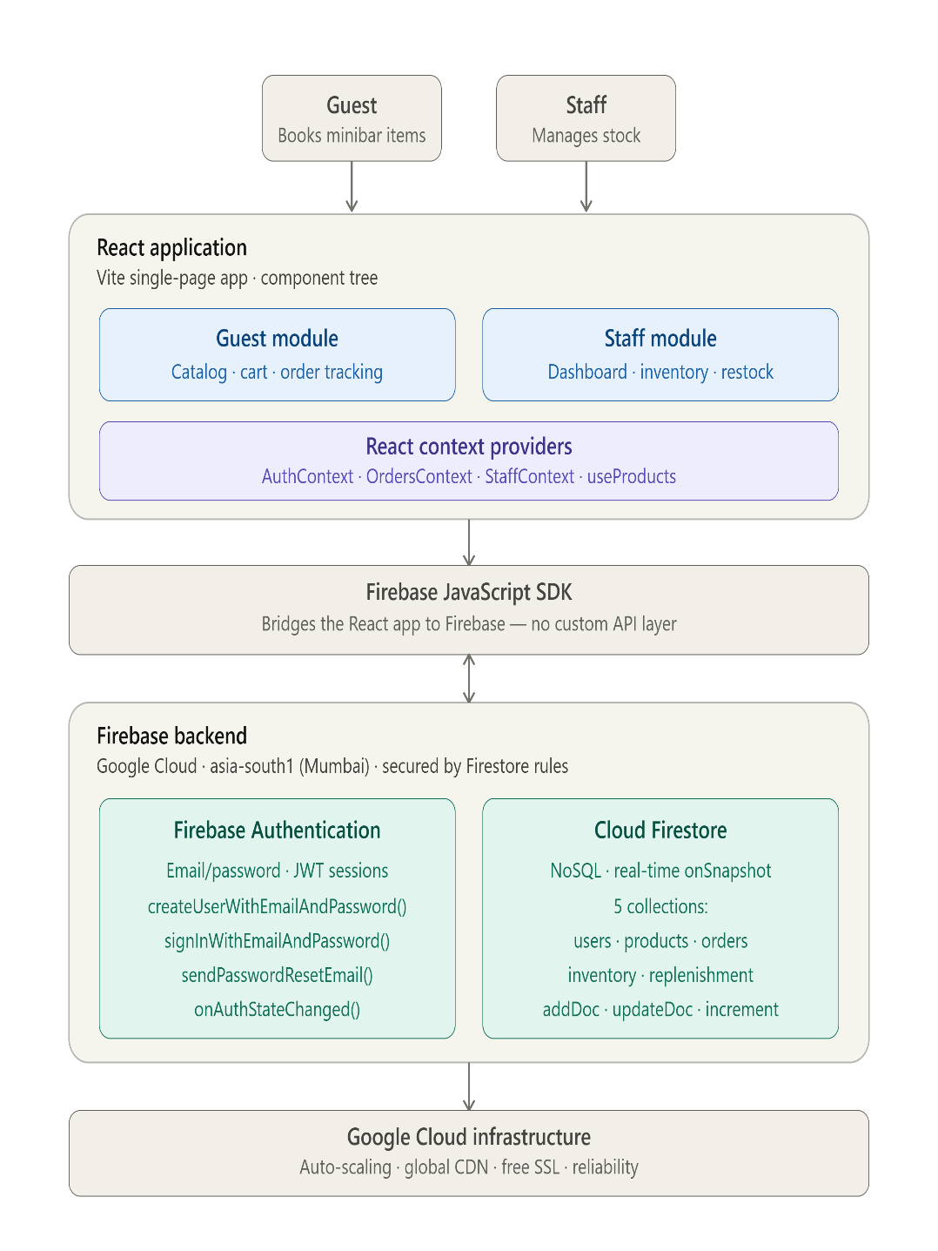

4.2 Description of Frontend Layer
The frontend layer of NAVIS is a single-page application (SPA) built with React.js and bundled using Vite. It is the only part of the system that users directly interact with, and it serves two distinct types of users — Guests and Staff — through separate modules within the same application.
The frontend is organised as a component tree, where the interface is broken down into small, reusable components. The Guest module provides the product catalog, shopping cart, and order tracking, allowing guests to browse the 24 minibar products, place orders, and view the live status of those orders. The Staff module provides a dashboard, inventory management, and restock controls, allowing staff to monitor stock levels, manage orders, and raise replenishment requests.
State across the application is managed using the React Context API rather than passing data manually between components. Four providers handle this shared state: AuthContext stores the currently logged-in user and session, OrdersContext manages the guest's orders, StaffContext supplies inventory and replenishment data to the staff dashboard, and the useProducts hook supplies the live product catalog. Navigation between pages — such as the catalog, cart, order tracking, staff dashboard, and authentication screens — is handled by React Router, which switches views instantly without reloading the page. Styling is achieved using Tailwind CSS together with CSS3, producing a clean, modern, and responsive interface that adapts to different screen sizes.
Importantly, the frontend communicates directly with the backend through the Firebase JavaScript SDK, without any custom API layer in between. Because the application uses Firestore's real-time onSnapshot() listeners, the interface updates automatically whenever underlying data changes — for example, a guest sees their order status change the moment a staff member updates it, and the staff dashboard reflects new orders or stock changes instantly, all without a manual page refresh.
4.3 Description of Backend Layer
The backend layer of NAVIS is provided entirely by Firebase, a Backend-as-a-Service (BaaS) platform from Google that runs on Google Cloud infrastructure. Instead of building and maintaining a traditional server, database, and custom API, the project relies on ready-made, fully managed cloud services that connect directly to the frontend. This serverless approach removes the need for server setup, manual scaling, and ongoing maintenance. The backend is composed of two core services: Firebase Authentication and Cloud Firestore.
Firebase Authentication handles all user identity management using the email/password sign-in method. It manages guest registration through createUserWithEmailAndPassword(), staff login through signInWithEmailAndPassword(), and password recovery through the built-in sendPasswordResetEmail() flow. Sessions are secured using JWT (JSON Web Tokens), and the onAuthStateChanged() listener automatically restores a user's session so they remain logged in after refreshing the browser. Guests register with their personal details, while staff accounts are created manually through the Firebase Console using an Employee ID convention (employeeid@navis.hotel).
Cloud Firestore serves as the primary database for all application data, stored as documents across five collections — users, products, orders, inventory, and replenishment. It operates in real time: when data changes, Firestore pushes the update instantly to all connected clients through persistent listeners. Data is created using addDoc(), modified using updateDoc(), and stock levels are adjusted safely using the increment() atomic operation. Server-generated timestamps ensure consistency across time zones. The database is hosted in the asia-south1 (Mumbai) region for optimal performance for Indian users.
Security at the backend is enforced through Firestore Security Rules — a declarative rules language that runs on Firebase's servers and cannot be bypassed by the client. The current rules require a valid authentication session (request.auth != null) for every read and write operation, ensuring the database is completely inaccessible to anyone who is not logged in. Finally, the entire backend is managed through the Firebase Console, which provides a complete web dashboard for managing data, users, security rules, and the composite index that supports the guest orders query. All of this runs on Google Cloud infrastructure, which delivers automatic scaling, a global CDN, free SSL, and high reliability without any additional configuration.

CHAPTER 5 – APPENDICES

5.1 Screenshots of the app

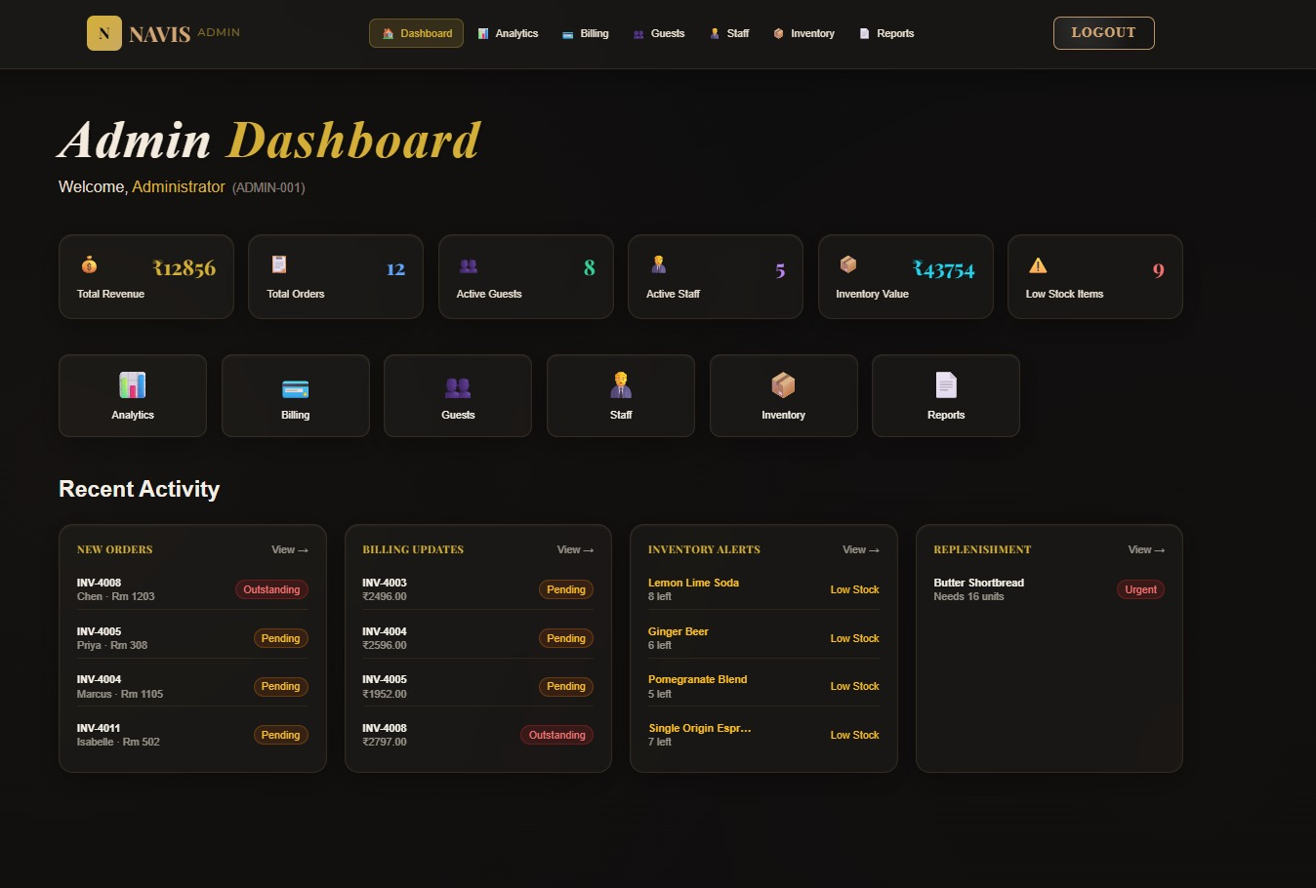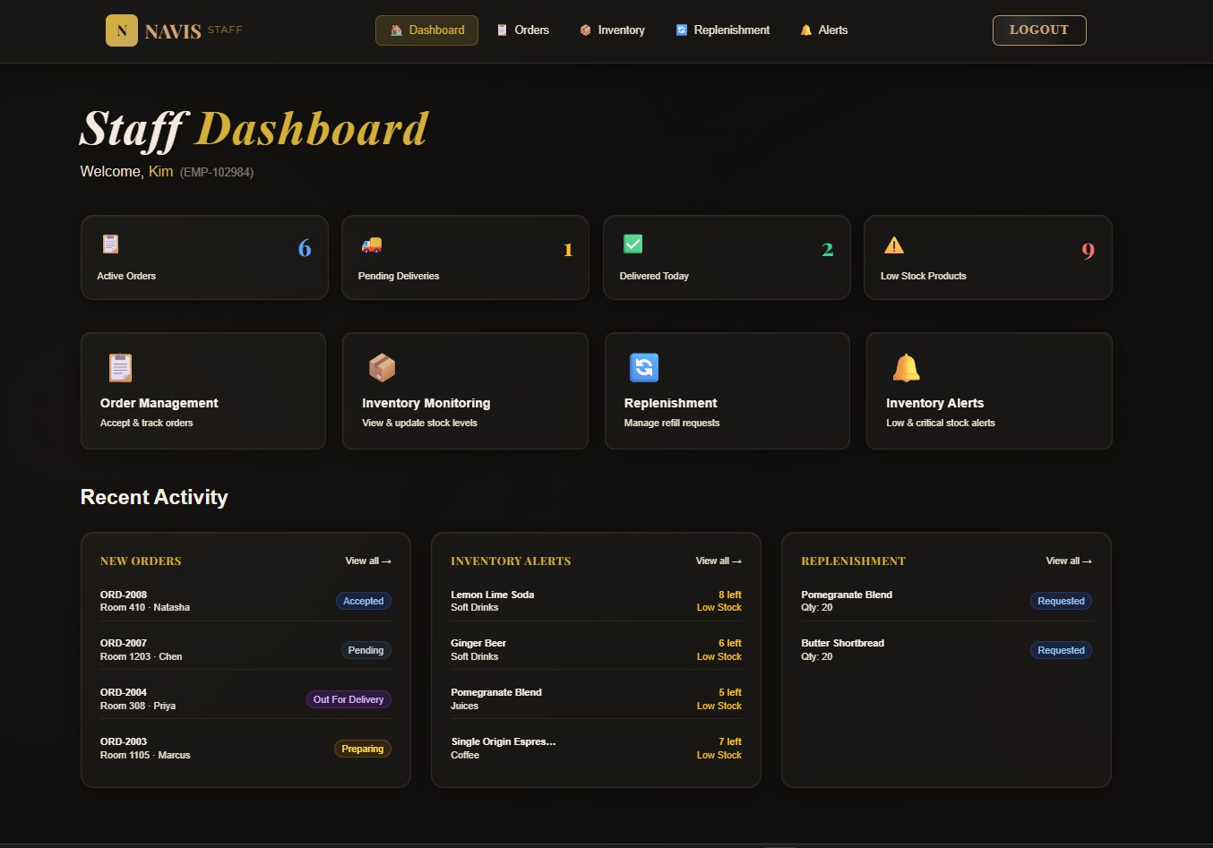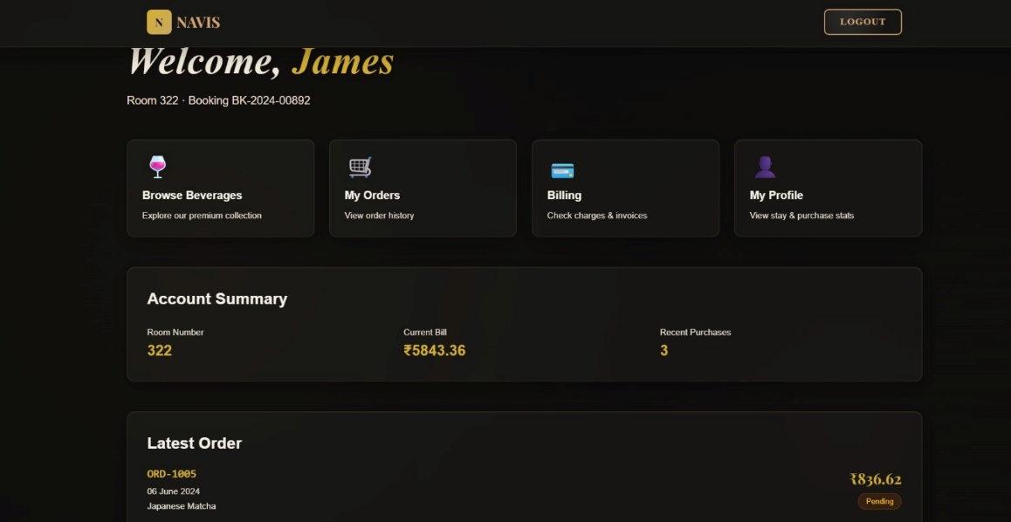
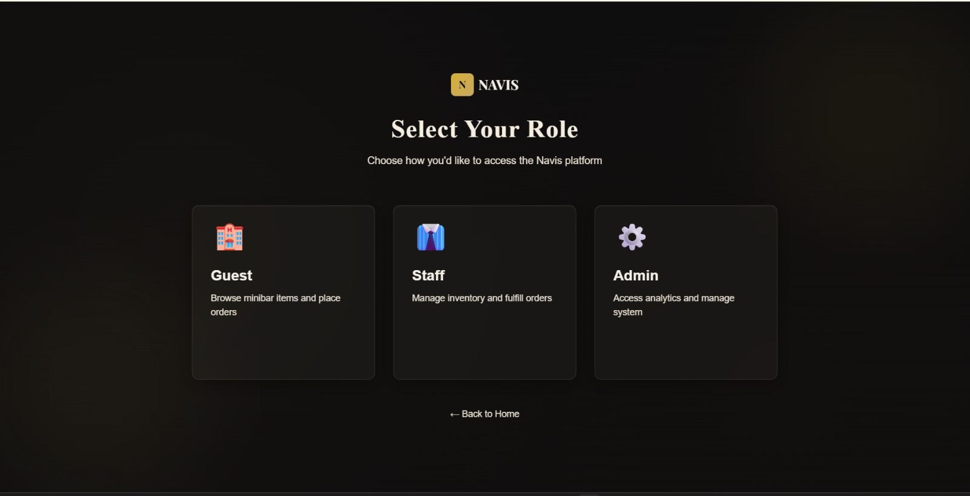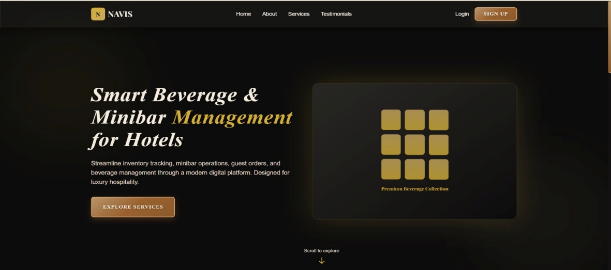

5.2 Sample code snippets
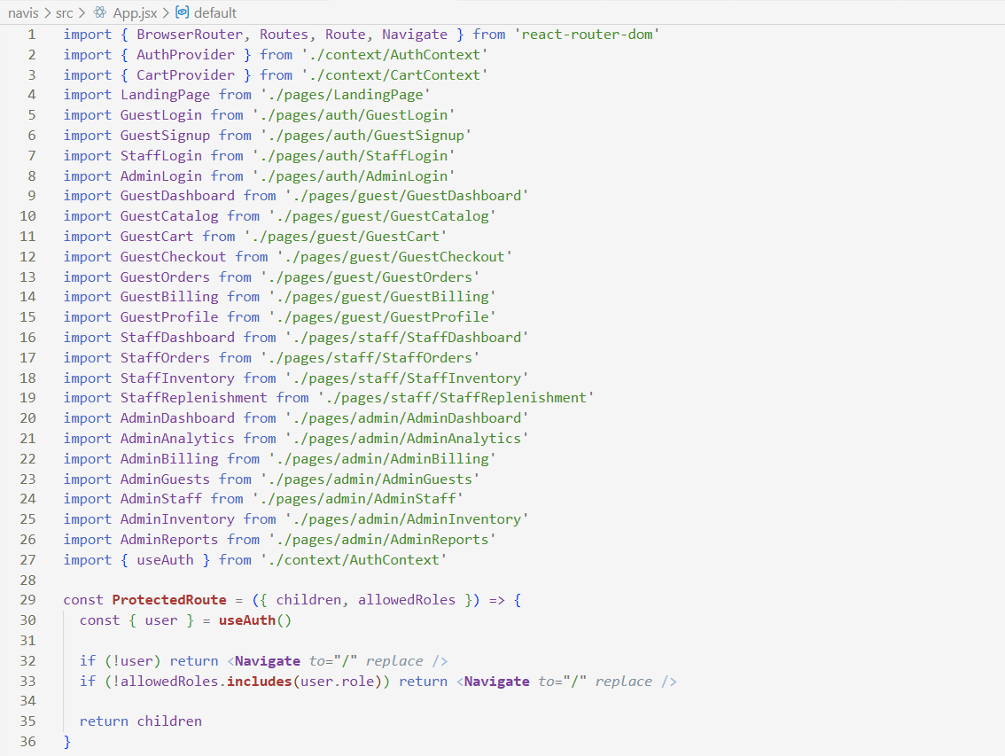
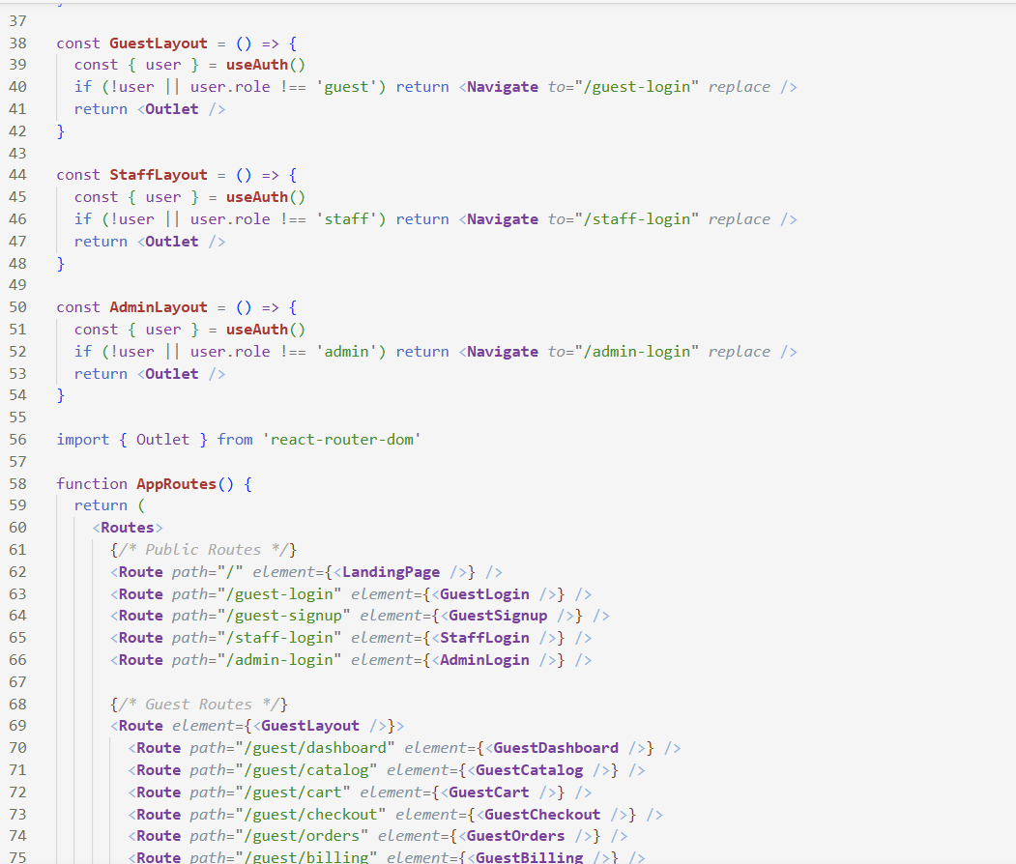

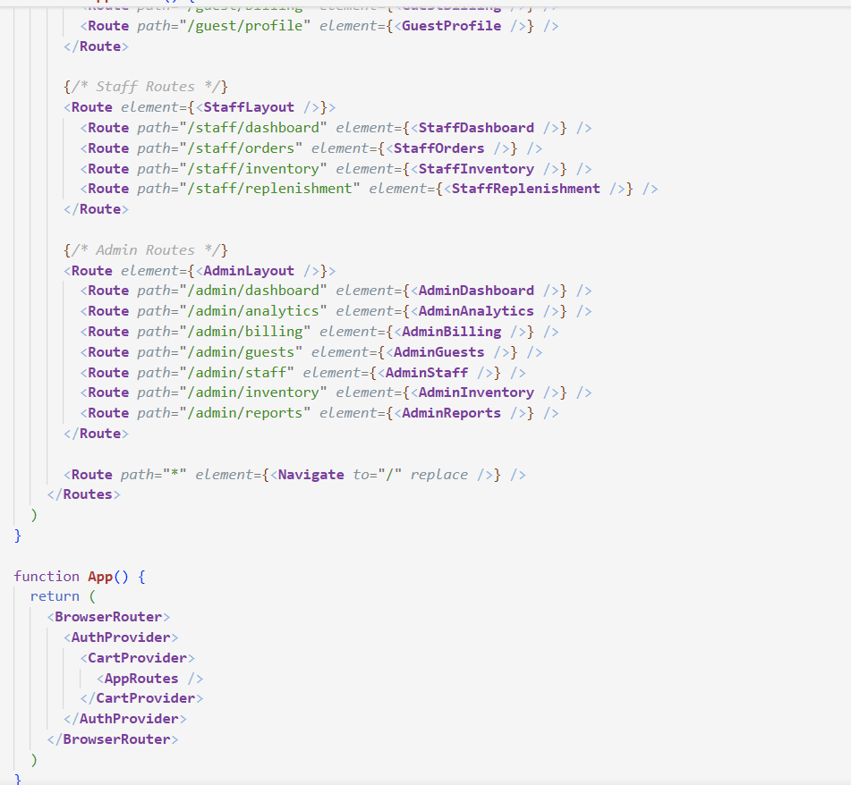
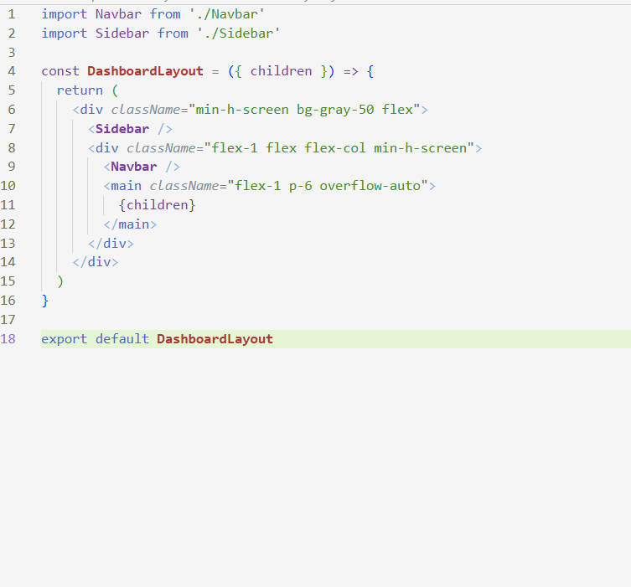

CHAPTER-6 ER DIAGRAM/DATABASE SCHEMA

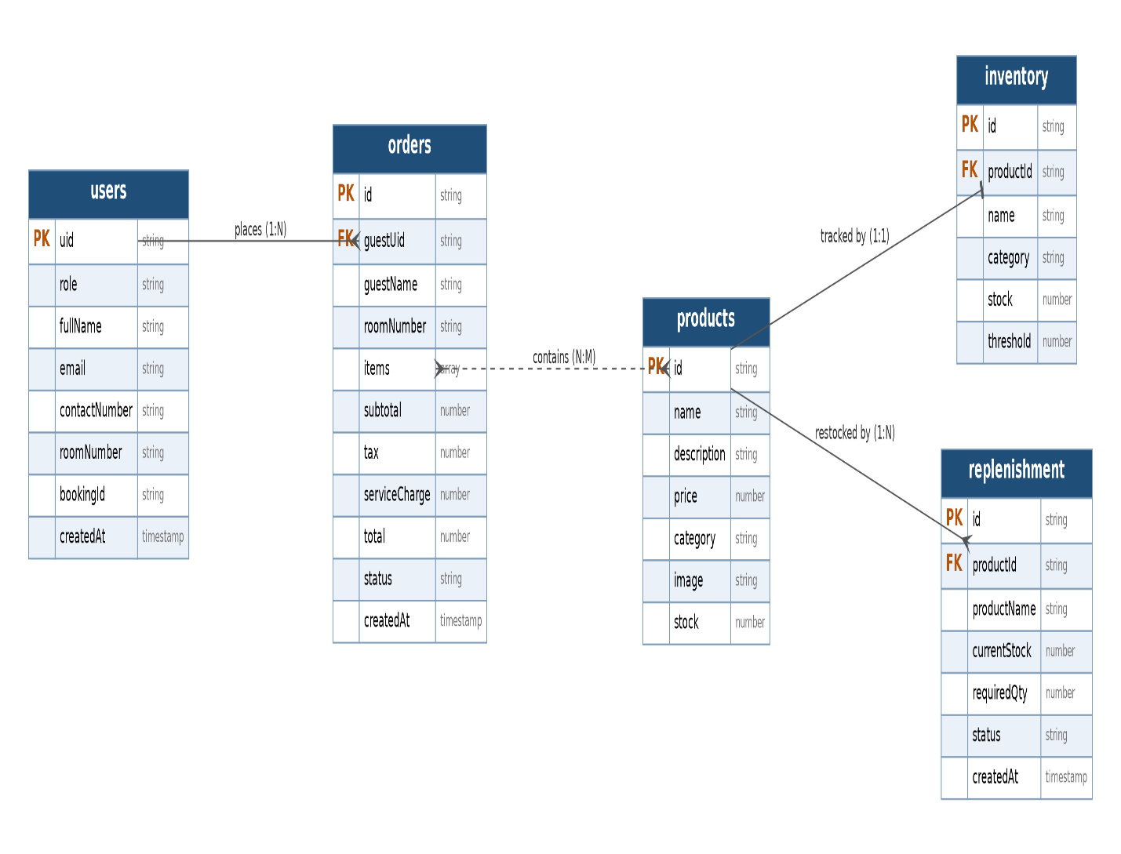

CHAPTER – 7 IMPLEMENTATION

7.1 Module-Wise Implementation

NAVIS is developed using a modular approach, where each module is designed to perform a specific function. This improves scalability, maintainability, and makes the system easier to understand and manage. All modules are interconnected to provide a smooth and unified user experience.
The Authentication Module handles user registration, login, and role-based access control. It ensures secure entry into the system by differentiating between three types of users — Guest, Staff, and Admin — each with their own login form and access scope. This module serves as the entry point of the entire system.
The Home and Guest Interaction Module acts as the customer-facing interface where guests can browse available beverages, explore featured minibar packages, read about the NAVIS service, submit feedback, and navigate to other sections. It is designed to provide a smooth and engaging experience for hotel guests.
The Inventory and Consumption Module manages the core operational data of the minibar system. Staff and Admin can track stock levels, record beverage consumption, manage inventory updates, and monitor room-wise minibar status. This module ensures that the minibar is always accurately stocked and accounted for.
The Orders and Replenishment Module handles the task workflow for fulfilling guest orders and managing refill requests. Guests can place beverage orders, while Staff receive and act on replenishment tasks. Both Staff and Admin can track the status of orders and ensure timely service delivery.
The Billing and Reports Module is exclusively accessible to the Admin and serves as the management control center. It generates itemized bills, tracks revenue, produces analytical reports, and provides insights into consumption patterns and operational performance.
In conclusion, the modular design of NAVIS ensures a smooth workflow, clear separation of responsibilities, and a better experience for all users — guests, staff, and administrators alike. Each module works independently but is fully integrated to form a complete and efficient hotel minibar management system.

7.2 Front-End Logic (UI Rendering and State Management)

The front-end of NAVIS — the Hotel Minibar Management System — provides a simple and efficient interface for managing minibar inventory, guest orders, and billing operations. It focuses on delivering a smooth user experience for tasks such as beverage browsing, stock tracking, replenishment handling, and report generation.
Built using a React component-based architecture, the system divides the UI into reusable modules like authentication, guest home, inventory dashboard, orders panel, and admin billing page. This ensures consistency, easy maintenance, and scalability across all three user roles — Guest, Staff, and Admin.
The navigation flow is structured to guide users through role selection → login → role-specific dashboard → task execution → confirmation without page reloads, ensuring a fast and responsive experience across all modules.
State management is used to track dynamic data such as current minibar stock levels, room-wise consumption records, active guest orders, and replenishment task status. These values are carried across components and reflected accurately in the admin billing and report views.
The guest-facing module dynamically renders beverage listings, featured minibar packages, and order history based on the logged-in guest's room number and session data. Staff and Admin views conditionally display role-appropriate dashboards with proper access restrictions enforced at the component level.
Overall, the front-end ensures a responsive, modular, and user-friendly minibar management experience tailored to the operational needs of hotel staff, administrators, and guests.

7.3 Authentication and Authorization
The Authentication and Authorization module of NAVIS ensures secure access control, protects user data, and regulates permissions across all three user roles — Guest, Staff, and Admin. It is responsible for verifying user identity during login and controlling what actions each user can perform within the application.
The system uses a JWT (JSON Web Token) based authentication mechanism. During login, user credentials are verified against stored database records based on the selected role. Guest accounts are authenticated using name, contact number, room number, and password. Staff accounts use employee ID and password, while Admin accounts use a unique Admin ID and password. Passwords are securely hashed to ensure data protection.
The generated token is included in the header of all subsequent API requests, allowing the server to validate user identity without maintaining session data. This stateless approach improves scalability and performance of the system.
Role-Based Access Control (RBAC) is used to manage permissions across the platform. Guests can browse beverages, place orders, view order history, and submit feedback. Staff can access the dashboard, manage replenishment tasks, and update inventory records. Admin users have full access including inventory control, billing, analytics, and report generation.
On the front-end, conditional rendering ensures that only authorized options are visible based on the logged-in user's role. For example, admin-only functionalities such as billing and revenue reports are completely hidden from guest and staff views, and staff-specific modules like replenishment tracking are inaccessible to guests.
Additional security measures include token expiration, password complexity rules, and secure HTTPS communication to protect sensitive data. The system also handles authentication errors such as invalid credentials or expired tokens using proper HTTP status codes like 401 (Unauthorized) and 403 (Forbidden).
Overall, this module ensures a secure, role-based, and reliable access system for NAVIS while maintaining ease of use and operational efficiency across all user levels.
7.4 Back-end Logic
Since NAVIS uses Firebase as a Backend-as-a-Service, the backend logic is not written as server-side code on a separate machine. Instead, it is implemented through direct calls to Firebase services from within the React application using the Firebase JavaScript SDK, combined with rules and configuration defined in the Firebase Console. The backend logic covers four main areas: authentication, data writes, real-time data reads, and security enforcement.
Authentication Logic
When a guest submits the signup form, the application calls createUserWithEmailAndPassword() with the guest's email and password. Firebase creates a secure account and returns a user object containing a unique UID. The application then immediately creates a matching document in the Firestore users collection using that UID as the document ID, storing the guest's full name, contact number, room number, booking ID, role, and creation timestamp. For staff, the entered Employee ID is combined with the fixed convention employeeid@navis.hotel to construct the login email, and signInWithEmailAndPassword() is called. Password recovery is handled by sendPasswordResetEmail(), which makes Firebase send a secure, time-limited reset link to the guest's email — no custom backend code is required. Session handling is managed by the onAuthStateChanged() listener, which fires whenever the authentication state changes; this is wrapped in the AuthContext provider so that the user's session is automatically restored after a page refresh.
Data Write Logic
When a guest places an order, the application calls addDoc() to create a new document in the orders collection. The document stores the guest's UID and name, room number, ordered items, subtotal, tax, service charge, total, and a status field that begins at "Pending". A server-generated timestamp is added using serverTimestamp() so that all order times are consistent regardless of the client's local time zone. When staff update an order or inventory record, updateDoc() modifies specific fields in the existing document — for example, advancing an order's status. For stock level changes, the increment() atomic operation is used so that concurrent updates from multiple staff members are handled safely without overwriting one another.
Real-Time Read Logic
The core of the backend logic is real-time synchronisation, implemented with onSnapshot() listeners in three contexts. In OrdersContext, the application subscribes to the orders collection filtered by the logged-in guest's UID, so when staff change an order's status, the update appears on the guest's screen instantly. In StaffContext, the application subscribes simultaneously to the entire orders, inventory, and replenishment collections, keeping the staff dashboard live. In the useProducts hook, the application subscribes to the products collection, so any product change made through the Firebase Console appears immediately in the guest catalog without a code deployment or refresh. The guest orders query combines a where clause (filtering by guestUid) with an orderBy clause (sorting by createdAt descending), which requires a composite index created in the Firebase Console to run efficiently.
Security Logic
Backend security is enforced through Firestore Security Rules, which run on Firebase's servers and cannot be bypassed by the client. The current rule requires a valid authentication session for every read and write operation, expressed as allow read, write: if request.auth != null. This ensures that the database is completely inaccessible to anyone who is not logged in, providing a reliable layer of protection independent of the frontend code.

CHAPTER 8 - FEATURES

8.1 List of Main Features
NAVIS is designed as a centralized digital system that manages hotel minibar operations, guest beverage orders, and administrative reporting through a single unified platform. The system is structured to streamline the complete minibar service lifecycle, from guest browsing and order placement to staff replenishment and admin billing.
One of the core components is the Beverage Browsing and Order Feature, which allows guests to explore available minibar items, view featured packages, and place orders directly from their room. This module ensures real-time visibility of available stock and accurate order tracking.
The Inventory and Consumption Feature enables staff and admin to monitor room-wise minibar stock, record beverage consumption, and manage replenishment updates. It ensures the minibar is always accurately tracked and restocked in a timely manner.
The Replenishment and Task Management Feature handles the workflow of refill requests and staff assignments. Staff receive and act on replenishment tasks, while admins can monitor the overall task status across all rooms.
The Billing and Revenue Feature provides the admin with a complete financial overview including itemized bill generation, revenue tracking, and consumption-based analytics. It ensures transparency in minibar charge management.
The Admin Dashboard and Reports Feature offers a centralized control panel for hotel administrators to monitor inventory levels, view operational reports, and track system-wide activity.
The Authentication and Security Feature ensures secure, role-specific access through login credentials and role-based access control for Guest, Staff, and Admin users. It protects sensitive data using encrypted authentication mechanisms.
Overall, these features work together to provide a smooth, efficient, and centralized minibar management experience, improving both guest satisfaction and hotel operational efficiency.

8.2 How Each Feature Works
NAVIS operates through a seamless interaction between the user interface, backend APIs, and database systems. Each feature is designed to provide a simple user experience while handling complex operations in the background such as order validation, stock management, and billing computation.
1. Beverage Browsing and Order Feature
User perspective: Guests log in and are presented with the minibar home page showing available beverages and featured packages. They can browse items, view details, and place orders directly linked to their room number.
Technical perspective: The front-end sends API requests to the backend, which fetches current inventory data from the database. Once an order is placed, it is stored in the orders table linked to the guest's room and session. Real-time stock checks ensure items out of stock are not shown as available.
2. Authentication and Role Management Feature
User perspective: Users select their role — Guest, Staff, or Admin — during login and are directed to their respective dashboards with access limited to their permitted features.
Technical perspective: User credentials are validated based on role-specific fields. Passwords are hashed using bcrypt and stored securely. JWT tokens manage user sessions and are validated on every protected API request.
3. Inventory and Consumption Tracking Feature
User perspective: Staff and Admin can view current stock levels for each room's minibar, record consumed items, and update inventory after restocking.
Technical perspective: Inventory records are maintained in the database with room-wise entries. API endpoints handle stock read, update, and consumption recording operations with validation to prevent negative stock values and maintain data consistency.
4. Orders and Replenishment Feature
User perspective: Guests can place beverage orders from their room. Staff receive replenishment tasks on their dashboard and mark them as completed after restocking.
Technical perspective: Order creation triggers a replenishment task entry in the database. Staff-facing APIs fetch pending tasks filtered by assignment and update task status upon completion. Admins can monitor all active and resolved replenishment records.
5. Billing and Revenue Feature
User perspective: The Admin can generate itemized bills for each room based on recorded consumption, view total revenue, and export reports for a given time period.
Technical perspective: Billing data is computed by aggregating consumption records from the database against item pricing. API endpoints return structured billing summaries that are rendered as reports in the admin dashboard.
6. Admin Dashboard and Reports Feature
User perspective: Admins access a centralized panel showing inventory levels, pending replenishments, total revenue, and analytical summaries of minibar usage across all rooms.
Technical perspective: The dashboard fetches aggregated data from multiple API endpoints covering inventory, orders, and billing. Analytics are computed server-side and returned as structured JSON for efficient rendering on the front-end.
7. Feedback Feature
User perspective: Guests can submit feedback about their minibar experience directly from the home page without navigating away from the interface.
Technical perspective: Feedback submissions are sent via POST requests to the backend and stored in a dedicated feedback table linked to the guest's session. Admin can retrieve and review feedback through the dashboard.
8. System Integration Feature
User perspective: All five modules — Authentication, Guest Home, Inventory, Orders, and Billing — work together seamlessly within a single platform without requiring the user to switch between separate systems.
Technical perspective: A RESTful architecture connects the React front-end, Node.js and Express.js backend, and the database, ensuring smooth and consistent data flow between all modules for every user role.

CHAPTER -9 CHALLENGES & LIMITATIONS

9.1 Issues Faced During Development

Currency and data consistency
All three modules (Guest, Staff, Admin) were built with separate mock data files. When currency was changed from dollars to rupees, prices had to be updated in three different places — mockData.js, StaffContext.jsx, and AdminContext.jsx — and any mismatch caused inconsistent figures across modules.

Product image mismatch
The initial Unsplash URLs were generic placeholder images that didn't match product names. A cola card was showing a perfume bottle, a shortbread card was showing the same image as crackers. Each URL had to be individually researched and replaced with a product-appropriate photograph.

Dollar sign replacement in JSX
When replacing $ with ₹ across all JSX files, a Python script was used for bulk replacement. However the script incorrectly replaced JavaScript template expression syntax like ${variable} in some files — for example ${paidBills} became ₹{paidBills} which broke the rendered output. Filenames like ${inv.id}.csv were also affected.

React Context scope
The three modules each have their own context providers (CartContext, OrdersContext, StaffContext, AdminContext). Because they were built separately, the Guest module's placed orders do not feed into the Staff module's order queue, and neither feeds into the Admin billing system. Each module operates on its own independent dataset.

Recharts not in original dependencies
The analytics charts in the Admin module use the Recharts library, but it was not included in the original package.json. Anyone who received the earlier ZIP before the final version would get a blank analytics page with a module-not-found error on npm run dev.

Stock quantity not updating on order placement
When a guest places an order through the checkout flow, the inventory stock count in the Staff and Admin modules does not decrease. The order is placed into OrdersContext but there is no connection between that and the stock field in either StaffContext or AdminContext.

Admin analytics showing hardcoded revenue in INR values
The analytics chart revenue figures (revenueData in AdminContext) were originally in dollar scale (3200, 4100 etc.) and when the currency was switched to rupees, those figures were scaled up proportionally but the chart axis tick formatter still needed a manual fix to show ₹ instead of $. .

9.2 Solutions Applied

Currency consistency — All three data files were updated in a single pass. Prices were converted using a fixed multiplier (approximately ₹83 per dollar, rounded to clean INR figures like ₹375, ₹499, ₹999) so amounts look realistic rather than like mechanical conversions.

Product images — Each of the 24 products was given a manually verified Unsplash URL. Search terms were kept specific (e.g. "espresso cup overhead", "pomegranate juice glass", "butter shortbread cookies") to ensure the photograph actually matches what the product is.

Template expression breakage — After the bulk replacement, a targeted Python script ran a second pass to detect and restore broken patterns. Specific known cases (₹{paidBills}, ₹{convRate}, the CSV download filename) were fixed individually. A final grep scan confirmed no remaining broken expressions.

Recharts dependency — Added "recharts": "^2.12.7" to the dependencies block in package.json. The final ZIP includes this so npm install fetches it automatically.

Dollar-sign replacement in JSX — The replacement logic was made context-aware: only patterns where $ appeared immediately before a .toFixed() call, or as a standalone string ("$"), or in a template literal before a currency value were replaced. Pure JavaScript template syntax ${expression} was preserved.

Separate module data — Since connecting the contexts would require a significant architectural refactor, the decision was made to keep them separate with realistic but independent mock data. Each module has its own complete dataset that accurately reflects what a real system would show, even if they don't share live state.

9.3 Current Limitations or Known Bugs

No shared state between modules
The biggest architectural limitation. A guest placing an order in the Guest module does not create a corresponding order in the Staff module's order queue. Similarly, staff marking an order delivered does not update the guest's order history. Each module is a self-contained simulation.

No data persistence
All state lives in React's memory. Refreshing the browser resets everything — cart items, order status changes, stock edits, replenishment requests — back to the initial mock data. The only thing that persists across a refresh is the login session stored in localStorage.

Authentication is not real
The login forms accept any input. There is no password validation, no credential checking, and no session security. Typing anything into the login fields and submitting will always succeed. This is intentional for a frontend demo but means the app cannot be deployed as-is.

No role enforcement on routes
React Router does not protect routes. If a user knows the URL /admin-dashboard, they can navigate there directly without logging in as an admin. The useEffect redirect in each page catches this and redirects to the login page, but only after the component mounts — there is a brief flash before the redirect.

Inventory stock does not decrease on purchase
When a guest checks out, the product stock counts in the Staff and Admin inventory views do not change. Orders and inventory are tracked in separate contexts with no bridge between them.

Recharts renders blank on very small screens
The ResponsiveContainer in the analytics charts collapses to zero height on screens narrower than about 360px. The charts disappear entirely on very small mobile screens without an error message.

Currency formatting without locale
Rupee amounts are displayed as plain numbers with a ₹ prefix (e.g. ₹1,165.00). There is no use of Intl.NumberFormat with Indian locale, so large numbers like ₹14,590 are not formatted with the Indian numbering system (lakhs/crores grouping) — they use standard Western thousand-separators.

Images dependent on external CDN
All 24 product images are hosted on Unsplash. If Unsplash is unavailable, rate-limits the requests, or changes the image URLs, all product images will fail to load. An onError fallback exists on each <img> tag but it points to another Unsplash URL, so it would also fail in the same scenario.

No form validation on checkout
The checkout page accepts empty or invalid inputs for name, room number, and payment details without showing errors. A user can place an order with blank fields.

Admin reports export as plain text, not true PDF
The "Download PDF" button in the Reports Center generates a .txt file rather than an actual PDF. This is a known limitation of the frontend-only constraint — generating real PDFs requires either a server-side library or a client-side library like jsPDF which was not included in the project dependencies.

CHAPTER -10 FUTURE ENHANCEMENTS

10.1 Planned Features

NAVIS — Minibar and Beverage Inventory — has been designed as a scalable and extensible web application that can be enhanced with advanced features in future iterations. While the current system successfully supports core functionalities such as role-based authentication, guest beverage ordering, inventory tracking, staff replenishment management, and admin billing, several improvements are planned to further enhance usability, automation, performance, and user experience.
One of the major planned enhancements is the integration of an AI-based recommendation system. This system will analyze guest preferences, order history, and frequently consumed beverages to suggest personalized minibar items automatically. For example, if a guest frequently orders a particular category of beverages, the system will prioritize similar items and suggest curated minibar packages based on past behavior and seasonal trends.
A mobile application version of the platform is also planned for both Android and iOS devices. The mobile app will provide guests with faster access to beverage browsing, push notifications for order status updates, and real-time replenishment confirmations, improving the overall in-room experience.
To improve billing transparency and payment flexibility, future updates will include integration with secure third-party payment gateways such as Razorpay or Stripe. This will allow guests to settle minibar bills digitally using UPI, credit or debit cards, or net banking, with automated invoice generation sent directly to their registered contact.
An advanced admin dashboard is also planned to help hotel administrators monitor room-wise consumption trends, revenue patterns, inventory utilization rates, and staff performance. This dashboard will include graphical analytics such as charts and exportable reports to support data-driven decision-making.
Future versions of NAVIS will also include a guest review and rating module, allowing guests to rate individual minibar items and overall service quality. This will help improve service standards and provide the admin with actionable feedback on product offerings.
A real-time notification and alert system will be introduced, enabling staff to receive instant replenishment task alerts and allowing guests to track their order status through email or in-app notifications.
Additionally, a chatbot-based guest support system is planned for future implementation. This chatbot will assist guests with beverage queries, order placement guidance, and instant support without requiring human intervention at the front desk.
Finally, the system is expected to evolve into a highly scalable architecture by adopting microservices in the backend. This will allow independent scaling of modules such as inventory, orders, and billing, ensuring better performance, maintainability, and fault tolerance as the system scales across larger hotel properties.
In conclusion, the planned features aim to transform NAVIS into a fully intelligent, guest-friendly, and enterprise-ready minibar management system that delivers a seamless hospitality experience across all user roles.

10.2 Possible Integrations or Optimizations
As NAVIS evolves into a more advanced and scalable digital platform, several integrations and optimizations can be introduced to significantly improve performance, usability, security, and system efficiency. The current system already provides a complete end-to-end minibar management workflow including role-based authentication, guest ordering, inventory tracking, replenishment task management, and admin billing. However, future enhancements can transform it into a highly intelligent, enterprise-grade hospitality management ecosystem.
One of the most impactful integrations is the adoption of real-time inventory synchronization APIs. Currently, the platform manages stock data through manual staff updates. By integrating IoT-enabled minibar sensors or hotel property management system APIs, the platform can ensure automatic stock level updates, instant low-stock alerts, and accurate consumption recording without manual intervention.
Frequently accessed data such as beverage listings, room-wise inventory status, and pricing details can be cached using tools like Redis, reducing repeated database calls and improving overall application response time, especially during peak hotel occupancy periods.
A key enhancement for operational efficiency is the integration of a real-time notification system. Using services such as Firebase Cloud Messaging or WebSocket, staff can receive instant replenishment task alerts and guests can receive live order status updates. This ensures continuous operational engagement and reduces service delays.
From a frontend optimization perspective, implementing lazy loading and code splitting in React will improve application performance. By loading only required components on demand — such as the billing module or inventory dashboard — the initial load time of the application can be significantly reduced, especially on mobile devices used by hotel staff.
Another important improvement is the integration of OAuth-based social login, allowing guests to sign in using Google or Apple accounts, reducing friction during registration. Additionally, multi-factor authentication can be added for admin and staff access to sensitive billing and inventory operations.
For better system monitoring, integration with logging and performance tracking tools such as Prometheus and Grafana can be introduced. These tools will help track system health, detect errors in real time, and analyze usage patterns to improve operational efficiency across all modules.
AI-based consumption forecasting is another valuable optimization. Machine learning algorithms can analyze historical minibar usage patterns, peak occupancy periods, and seasonal trends to predict stock requirements and suggest optimal restocking quantities. This will reduce waste, prevent stockouts, and improve resource utilization.
A Progressive Web Application upgrade is also a valuable future optimization. Converting NAVIS into a PWA will allow hotel staff to access inventory and replenishment modules on their devices with offline capability and push notifications, without requiring a native mobile application installation.
Security can be further strengthened through advanced encryption standards and stricter role-based access control policies. This ensures that guest data, billing records, and inventory details remain encrypted both in transit and at rest, complying with hospitality data protection standards.
Integration with hotel Property Management Systems such as Opera or Cloudbeds is another significant planned optimization. This will allow NAVIS to automatically sync guest check-in and check-out data, link minibar charges directly to room bills, and streamline the overall hotel billing workflow without manual reconciliation.
Finally, integrating detailed analytics dashboards for administrators will provide insights into beverage consumption trends, revenue generation per room category, staff task completion rates, and guest ordering behavior. This will support strategic decision-making and optimization of minibar product offerings and pricing.
In conclusion, the proposed integrations and optimizations aim to transform NAVIS into a highly scalable, intelligent, and secure minibar management platform. These enhancements will ensure better performance, operational efficiency, and long-term sustainability as the system grows to serve larger hotel properties.

CHAPTER - 11 CONCLUSION
11.1 Summary of the Project
NAVIS is a comprehensive web-based hotel minibar management system designed to streamline the complete minibar service lifecycle — from guest beverage browsing and order placement to staff replenishment and admin billing — through a single unified digital platform. The primary objective of the project is to eliminate the manual and fragmented nature of traditional hotel minibar operations by integrating guest interaction, staff task management, and administrative control into one centralized, role-based system.
The motivation behind this project arises from the operational inefficiencies faced by hotel staff when managing minibar inventory manually across multiple rooms, and the lack of a transparent and convenient ordering experience for guests. In modern hospitality environments, guests expect seamless in-room services, while hotel administrators require accurate consumption data and real-time billing. Existing systems often lack integration, role-specific access, and real-time tracking. NAVIS addresses these challenges by providing a structured platform that simplifies minibar management for all three stakeholders — Guest, Staff, and Admin.
The conceptual framework of the system focuses on providing an intuitive role-based workflow. Guests can browse beverages, place orders, and track their order history. Staff access a task dashboard to act on replenishment requests and update inventory records. Administrators manage billing, view consumption analytics, and generate operational reports. This structured approach ensures clarity, operational efficiency, and accountability across all levels of hotel minibar management.
From a technical standpoint, the system is developed using modern full-stack web technologies. The frontend is built using React.js, enabling a dynamic component-based architecture that enhances reusability and performance. The backend is powered by Node.js and Express.js, providing modular API endpoints for each functional module. JWT-based authentication ensures secure, stateless session management, while role-based access control regulates permissions across Guest, Staff, and Admin users.
The system architecture follows a modular and scalable design approach. Each functional module — Authentication, Guest Home and Ordering, Inventory and Consumption, Orders and Replenishment, and Billing and Reports — is independently structured to ensure maintainability and future extensibility. This modularity supports easy enhancement of individual modules without affecting the overall system and allows future migration to a microservices architecture if required.
The development process followed a structured Software Development Life Cycle approach, ensuring systematic progression from requirement analysis to deployment. Functional and non-functional requirements were gathered based on hotel operational workflows. The design phase focused on defining role-specific user flows and wireframes. Implementation was carried out in iterative stages, where each module was developed and tested independently before integration. Version control was maintained using Git throughout the development process.
Testing played a crucial role in ensuring system reliability. Functional testing was conducted to verify that each module performed as expected, including login authentication, inventory updates, and billing computation. Integration testing ensured seamless communication between different components. UI testing validated responsiveness and usability across devices. Error-handling mechanisms were tested to ensure system stability under invalid inputs or unexpected user actions.
From a user experience perspective, the system is designed with simplicity and role-appropriate access as core principles. Guests navigate a clean and focused home interface. Staff operate through a task-driven dashboard. Admins access a comprehensive control panel with billing and analytics capabilities. Each role receives only the information and actions relevant to them, reducing complexity and improving operational efficiency.
In conclusion, NAVIS successfully integrates guest ordering, staff operations, and admin management into a unified minibar management platform. It demonstrates the practical application of full-stack development principles, modular software design, and user-centered thinking, while providing a strong foundation for future enhancements such as IoT integration, AI-based forecasting, and mobile application development.

11.2 What Was Achieved
NAVIS represents a significant achievement in the development of a modern, role-based digital management system for hotel minibar operations. The project successfully delivers a fully functional web-based platform that integrates guest interaction, staff task management, and administrative control into a single unified system. Through careful planning, structured development, and iterative testing, the system demonstrates the effective application of full-stack web development concepts, UI/UX design principles, and scalable software engineering practices.
One of the major achievements of this project is the successful implementation of a three-role access system — Guest, Staff, and Admin — each with a distinct login flow, dashboard, and set of permitted operations. This role-based separation ensures that each user type interacts only with features relevant to their responsibilities, improving security, usability, and operational clarity.
From a frontend development perspective, the project successfully implements a responsive and interactive user interface using React.js. The component-based architecture ensures modularity, allowing reusable UI elements such as beverage cards, inventory tables, order panels, and billing summaries. Smooth navigation between role-specific pages is achieved using React Router, enabling a seamless multi-step experience for all three user types.
On the functional side, the project achieves a complete end-to-end minibar management workflow. Guests can log in, browse beverages, place orders, and view their order history. Staff can access pending replenishment tasks, update inventory records, and mark tasks as completed. Admins can generate itemized bills, track revenue, and view consumption-based analytics reports. Each step is logically connected, ensuring a smooth transition across all operational stages.
Another key achievement is the effective management of application state across components. By using React state management techniques, user inputs and session data are preserved across different stages of the workflow. This ensures continuity in the user journey, where inventory updates by staff are immediately reflected in the admin's billing and reporting view.
The project also successfully implements a structured inventory tracking system. Each room's minibar stock is independently monitored, with consumption entries linked to specific rooms and time periods. This structured format ensures scalability, allowing new rooms, beverages, or pricing configurations to be added without modifying the core application logic.
From a user experience perspective, one of the major accomplishments is the design of role-appropriate dashboards that present only relevant information to each user. Guests are not exposed to inventory data. Staff are not exposed to billing reports. This focused design reduces cognitive load and improves task efficiency across all user roles.
The billing module successfully consolidates room-wise consumption records and computes itemized bills dynamically. This ensures complete transparency in minibar charge management and provides the admin with accurate financial data for revenue tracking and reporting.
From a software design perspective, the project achieves a well-structured modular architecture. Each of the five modules is implemented as an independent unit with clearly defined responsibilities. This separation of concerns improves code maintainability, simplifies debugging, and supports future enhancements without disrupting existing functionality.
Security-related design considerations were incorporated throughout the system. JWT-based authentication ensures that all protected API routes are accessible only to verified and authorized users. Role-based access control is enforced both at the API level and through conditional rendering on the frontend, preventing unauthorized access to sensitive operations.
In conclusion, NAVIS successfully achieves its primary objective of digitizing and centralizing hotel minibar management through a unified, role-based platform. It delivers a complete, user-friendly, and scalable solution that demonstrates strong technical execution and thoughtful design, and stands as both an academic accomplishment and a practical demonstration of modern web development applied to real-world hospitality management challenges.

11.3 Skills Learned During Development
The development of NAVIS provided valuable practical exposure to real-world web application development in the context of hospitality management systems. It helped bridge the gap between theoretical concepts and their implementation in a structured, role-based software system. Throughout the project, we gained technical, analytical, and teamwork skills that are essential for modern full-stack development.
One of the key skills learned was frontend development using React.js. We gained experience in building component-based user interfaces, managing state across multiple pages, and handling routing between role-specific dashboards. Designing reusable components such as beverage cards, inventory tables, and order panels improved code efficiency and modularity. We also enhanced our understanding of responsive design using CSS, ensuring that the application works smoothly across different devices used by hotel guests and staff.
We developed a strong understanding of role-based application flow management. Since the system includes three distinct user roles — each with different dashboards, permissions, and workflows — we learned how to manage conditional rendering, protect routes, and maintain data continuity across different components and user sessions. This deepened our understanding of access control design and multi-role workflow architecture.
Another important learning area was backend development using Node.js and Express.js. We understood how RESTful APIs are structured, how HTTP requests and responses are handled, and how frontend and backend communication takes place through Axios. We also learned the importance of middleware for input validation and authentication enforcement.
Database design knowledge was also strengthened through structuring inventory, order, consumption, and billing data across multiple interconnected tables. We learned how to organize relational data efficiently to ensure scalability, accurate querying, and easy retrieval for reporting and analytics purposes.
The project also improved our UI/UX design skills. We learned how to design role-appropriate interfaces with clear navigation, visual hierarchy, and focused information display. Ensuring that guests, staff, and admins each had a distinct and intuitive experience taught us how to balance functionality with simplicity in real-world application design.
We gained experience in authentication and security implementation, including password hashing using bcrypt, JWT token generation and validation, and role-based route protection. This gave us practical insight into how modern web applications enforce secure access control at both the frontend and backend levels.
We also improved our version control practices using Git and GitHub, learning how to manage code changes, maintain project versions, and handle iterative development. This introduced us to professional development workflows used in industry settings.
Problem-solving and debugging skills were significantly strengthened through identifying and resolving issues related to role-based navigation, inventory update conflicts, state persistence across components, and billing computation accuracy. Each challenge improved our logical thinking and technical confidence.
Finally, the project helped us understand the complete software development lifecycle — from requirement gathering, system design, and iterative implementation to testing, debugging, and deployment readiness. It also improved our teamwork, communication, and technical documentation skills, which are essential for both academic and professional growth.
In conclusion, the development of NAVIS significantly enhanced our technical knowledge and practical skills. It provided comprehensive hands-on experience in building a complete, role-based full-stack web application and prepared us for more advanced software engineering challenges in the field of modern web and hospitality technology.

CHAPTER -12 References

12.1 Books, tutorials, APIs, documentation sites used
Official Documentation Sites
- React Documentation — React.js Official Docs. Available at: https://react.dev
- Vite Documentation — Next Generation Frontend Tooling. Available at: https://vite.dev
- Tailwind CSS Documentation — Utility-First CSS Framework. Available at: https://tailwindcss.com/docs
- React Router Documentation — Declarative Routing for React. Available at: https://reactrouter.com
- Firebase Documentation — Google Firebase Official Docs. Available at: https://firebase.google.com/docs
- Firebase Authentication Documentation. Available at: https://firebase.google.com/docs/auth
- Cloud Firestore Documentation. Available at: https://firebase.google.com/docs/firestore
- Firestore Security Rules Documentation. Available at: https://firebase.google.com/docs/firestore/security/get-started
- Node.js Documentation. Available at: https://nodejs.org/en/docs
- npm Documentation. Available at: https://docs.npmjs.com
- Git Documentation. Available at: https://git-scm.com/doc
- MDN Web Docs (HTML, CSS, JavaScript Reference) — Mozilla Developer Network. Available at: https://developer.mozilla.org
Tutorials and Learning Resources
- React Official Tutorial — "Quick Start." Available at: https://react.dev/learn
- Firebase — "Get Started with Cloud Firestore" Guide. Available at: https://firebase.google.com/docs/firestore/quickstart
- Firebase — "Add Firebase to Your JavaScript Project." Available at: https://firebase.google.com/docs/web/setup
- freeCodeCamp — React and Firebase Tutorials. Available at: https://www.freecodecamp.org
- W3Schools — HTML, CSS, and JavaScript Tutorials. Available at: https://www.w3schools.com
APIs and External Services
- Firebase JavaScript SDK Reference. Available at: https://firebase.google.com/docs/reference/js
- Firebase Authentication API (createUserWithEmailAndPassword, signInWithEmailAndPassword, sendPasswordResetEmail, onAuthStateChanged). Available at: https://firebase.google.com/docs/reference/js/auth
- Cloud Firestore API (addDoc, updateDoc, onSnapshot, increment, serverTimestamp). Available at: https://firebase.google.com/docs/reference/js/firestore_
- Firebase Console — Project Management Dashboard. Available at: https://console.firebase.google.com

